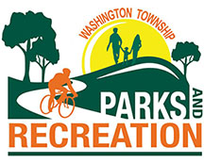
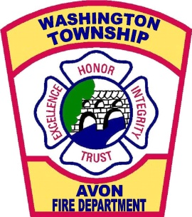
WASHINGTON TOWNSHIP

TOWNSHIP BOARD
Amanda Babinec
Steven D. Blacketer
Shane Sommers

HENDRICKS COUNTY

TRUSTEE

Don Hodson
311 Production Drive
Avon, IN 46123
Phone: (317) 272-1835

Resolution 111720-03
Washington Township Board Meeting Calendar for 2021
All meetings will be held at the Washington Township Government Center, 311 Production Drive, Avon, IN 46123. All meetings start at 3:00 PM unless otherwise noted.

- Tuesday, January 5, 2021
(Reorganization & monthly board meeting)
- Tuesday, February 9, 2021 @ 6:30pm
(Annual Report and State of the Township)
- Tuesday, March 9, 2021
- Tuesday, April 13, 2021
- Tuesday, May 11, 2021
- Tuesday, June 8, 2021
- Tuesday, July 13, 2021
- Tuesday, August 10, 2021
(2022 Budget Workshop followed by Regular Board Meeting)
- Tuesday, September 14, 2021
(Public Hearing for 2022 Budget followed by Regular Board Meeting)
- Tuesday, October 12, 2021
(Adoption of 2022 Budget and Regular Board Meeting)
- Tuesday, November 9, 2021
- Tuesday, December 14, 2021

Adopted this 17th day of November 2020.

________________________ ________________________
Shane Sommers, President Amanda Babinec, Secretary

Attest:
_______________________ ________________________
Steve Blacketer, Member Don Hodson, Trustee

